Set up Employee Self Service

Employee Self Service (ESS) enables employees to access their pay stubs via the web using a login and password.
There are two options for activating ESS; automated and manual.
**Note: the employee status in EOD/Go must be 'Active' in order for employee to be able to access ESS.
Automated Setup Procedures
Step 1 – In the employee information record, in the contact section, enter the employee’s email address.
Step 2 - Go to Product Access within the Ribbon menu in Employee records. All Active employees will be listed within the grid. If the employee’s contact email address is blank, the Email Address field will display in red.
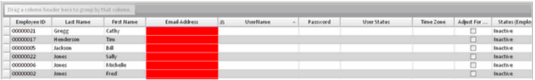
Step 3- Under “Status (Employee Self Service)” use the drop down and select “Active” to activate the registration process for an employee. Once you update all the employees you wish to activate, choose save from the menu. You will need to wait for a response letting you know the save is complete. If you exit before the save is completed the information will not be updated properly and some data may be lost. Once the save has been completed the “User Name” and “User Status” fields will update to “Registration Pending”.

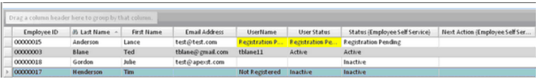
Step 4 - The employee will receive two emails, one with the registration password and one with a link to the registration website. The employee clicks on the link and enters the registration password on the next screen the employee will enter a user name and password to use going forward along with security questions.
The employee can access ESS after registering by going to https://selfservice.employerondemand.com/. Pay information is updated on Pay Date.
Next Action (Employee Self Service) - Select Resend Registration if the employee did not get the email or did not register within 45 days. Otherwise the Next Action is left blank.
Status (Employee Self Service)- The Status field is also used to deactivate an employee. If the employee record is changed to Inactive, the user account will automatically deactivate.
Special Notes: If the employee is activated for Online Time Clock and Employee Self Service the employee will get only one registration email and the user name and password can be used for both products.
User Name and Password can be changed by the employee under their Profile when they log in.
Option: In Company Information, under Reports in the Check Information section, you have the option to not produce check stubs for employees with Direct Deposit. This option was designed for employees who utilize ESS who will be checking

their pay stub online and have no need for a paper stub.
Troubleshooting
Under System > Logs > Email Log, make sure the system posted two emails going to the employee. Check the status of the emails, If the emails were successful the status should be “Sent”. It may take several minutes for the email to post and send.
If the employee does not receive the emails, have them check their spam folder. They can also check with their email provider to make sure they are not being filtered out.
Manual Setup Procedures
Step 1 - Go to Product Access within the Ribbon menu in Employee records. From the menu bar select Manual Maintenance.
Step 2 – A popup window will display. Enter in the User Name, Password and User Status, then check the box next to “Employee Self Service.”
**Note: User name must be at least 5 characters. Password must be at least 8 characters and contain 3 of the 4 following elements: Uppercase, lowercase, numerical & special characters. User name cannot be the same as other information in profile & password must not contain 3 or more consecutive characters within user name or full name.
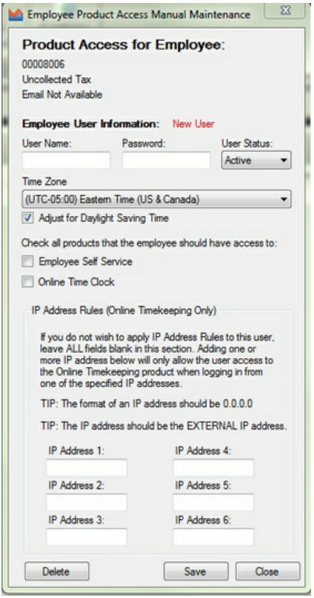

Step 3 – Save changes on completion of setup.
Step 4 – Provide the employer or employee the user information.
Employee is not required to have an email address if manual registration is used to set them up on ESS.
Special Notes: If the automated process was used to activate the employee they will need to register to have access to ESS. The employee will receive two emails, one with the registration password and one with a link to the registration website. The employee clicks the link and enters the registration password. On the next screen the employee will enter a user name and password to use going forward along with security questions. If the manual process was used to activate the employee, provide the employee with the username and password.
Employee Self Service Log In Procedures and Options:
Step 1 – The employee can access ESS by going to https://selfservice.employerondemand.com/.
**Note: the employee status in EOD/Go must be 'Active' in order for employee to be able to access ESS.
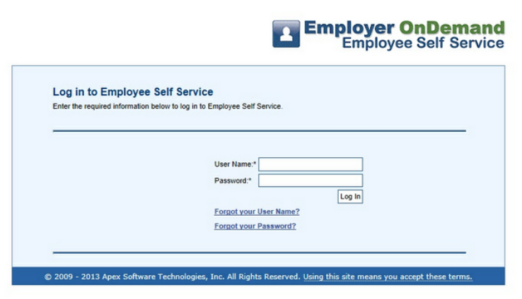
Step 2 – The employee will enter the User Name and Password and choose login. When the employee logs in the Pay Check Summary page defaults in.
All payroll information is updated on pay date. A new employee is able to update their personal information before their first paydate through the website; whether or not this information updates to Employer OnDemand / GO depends on the company level settings in Company Setup > Online Access and Settings > Online Access.
Employee Personal Information and filing status information loads from what is current in the employee information record in Employer OnDemand.
The Pay Check Summary located under Pay Info tab > Pay Stub will combine multiple checks received on the same check date.
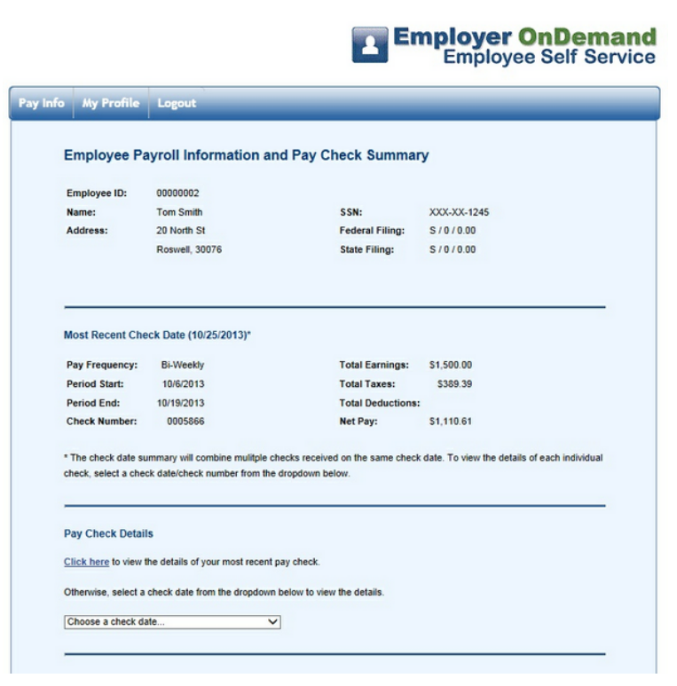
Pay Check Detail - Displays the most recent check date details or the employee can choose a previous check date.
Otherwise, select a check date from the drop down menu to view the details.
Print Preview - When selected, will pop up a window to allow the user to print their pay stub without the menu and header on the page.
Detailed Pay Information - Provides Gross to net pay information, along with current and year to date totals for earnings, taxes and accruals.
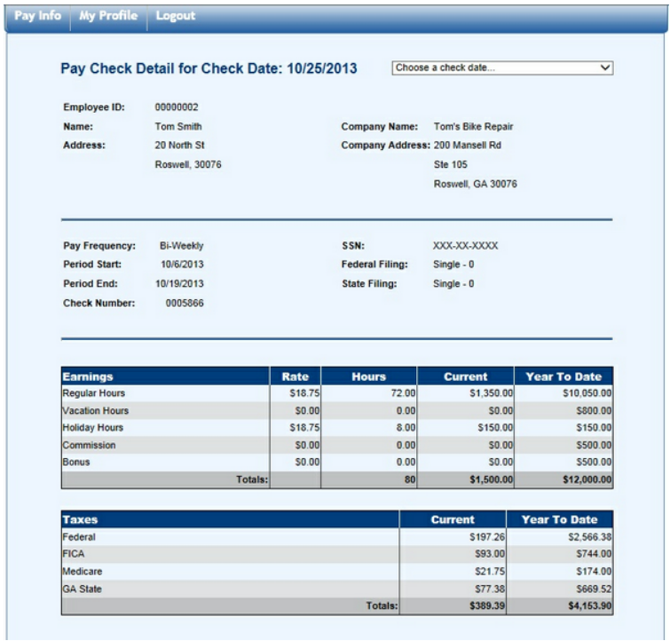
Year End Tax Forms - select an available* W2 from the drop-down menu to view details.
*if no data is available, this entire section will not display.
W2s are available for viewing on February 1st of the following year. 2013 W2s will be available on February 1, 2014.
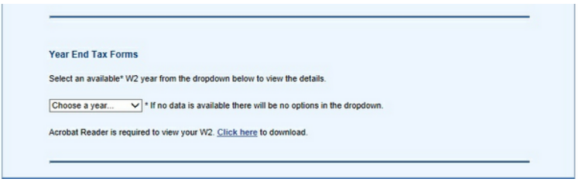
When employee selects the year, the W2 will appear in an additional window. If it does not, user should check browser settings to ensure popups are allowed on site.

